bre

Phi 2
usage guidelines

Document Owner | PHI Development TEAM | TBS Group S.p.A.  AREA Science Park - Padriciano, 99 - 34149 Trieste, Italty  Tel. +39 040 9229 1 - Fax +39 040 9229999
Document version | 1.0 – October 2012
Contact information | phi.technology@tbsgroup.com
Author | Francesco Bragagna

INDICE
1 Catalog Explorer 1
1.1 View Inside Catalog explorer 1
1.2 Class extension 1
1.3 Add attribute or shortcut 1
1.4 Add class method 1
1.5 Associate dictionary element to coded value 1
2 Class modification – simple relation 1
2.1 Add single String attribute without reference to other codes 1
2.2 add attribute like CodeValue to a class 1
2.3 Add date Attribute 1
2.4 Add Boolean Attribute 1
2.5 Add PQ attributes 1
2.6 Add IVL attribute (example IVL<Date>) 1
3 Class modification – advanced relation 1
3.1 List of attributes 1
3.2 Relation One to One 1
3.3 Relation Many to One (mono-directional) 1
3.4 Relation One to Many (monodirectional) 1
3.5 Relation Many to One (bidirectional) 1
3.6 Relation Many to Many 1
3.7 Create intermediate class for many to many relation 1
4 Actions 1
4.1 Read(), select() create(), delete() 1
4.2 Additional operation on Read (Select and Page size) 1
4.2.1 Select 1
4.2.2 Read Page size 1
4.2.3 Order by 1
4.3 Link/unlink 1
4.4 Inject/eject objects and list in conversation 1
4.5 Check if object is present in conversation 1
4.6 History of rim Objects 1
4.7 Temporary values 1
5 Designer widgets properties 1
5.1 List Elements Expression 1
5.2 Default Value 1
5.3 Read and search Filters 1
5.3.1 Read filters 1
5.3.2 Search filters 1
6 Business logic 1
6.1 Action methods 1
6.2 Set code value attribute based on OID 1
6.3 Set code value by CodeSystem, Domain, Code 1
6.4 Get EmployeeRole related to Current system user 1
6.5 Assign an author 1
6.6 Format date 1
6.7 Current time 1
6.8 Current process name 1
6.9 Current sub process name 1
6.10 Get integer part 1
6.11 End of line in Labels 1
6.11.1 Label outside of a table with a binding value 1
6.11.2 Label with text coming from translation 1
6.11.3 Label inside a table 1
6.11.4 Table header 1
6.12 Table column width 1
6.13 Widget style 1
6.14 Widget with object reference 1
6.15 Select Items coming from multiple domains. 1
7 Phi designer configurations 1
7.1 Password encryption 1
7.2 ID roots 1
8 Best practice and suggestions 1
8.1 Catalog server base classes usage 1
9 Runtime configurations 1
9.1 Integration Servlet 1
10 Subversion repository suggestions 1
11 PHI Previous version behavior not supported jet. 1
11.1 ValueEL 1

Catalog Explorer

Catalog explorer is completely renewed. It represents the list of classes used for store data available in Catalog Server and backend. They are colored as defined in HL7 standards.

Each Class extends one of main classes (Act, Entity, Role..) and it contains standard and custom attributes.

View Inside Catalog explorer

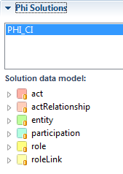
Under phi solution menu choose your solution.
Each solution can have different implementation made with Catalog Explorer.

Select the current solution under Phi Solutions, the Solution data Model is show.

The catalog explorer can be browsed to look available classes, actions attributes.

The catalog explorer view show initially the 6 main classes (act, entity…).
You can decide to extend one of them, ad add your attributes, or other action directly from the catalog explorer.

Opening one node, like act, you can see the list of classes which extends Act, including Act itself.

Inside each class you have two folder:
- actions
- properties

Inside action you can see the base Action list, and the action added as methods in Class Action class.

In properties you can see the ‘shortcuts’ to other classes, and the list of attribute of current classes.

The shortcut are represented with a square (, , ..) with different color depending on which class extends the shortcut (Act red, Role yellow, HL7 standards) and the attribute with a ball (). In case the attached element is a list/set, you can see a different icon representing the “list” ( or ).

Attribute representing a coded value present in the dictionary are represented with an icon with CV ()
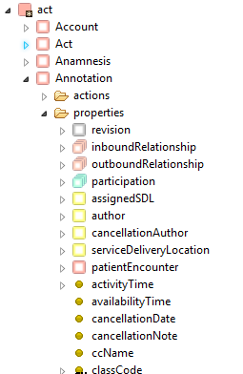

Property associated with complex type (e.g. ED, IVL, PQ, CV) can be open to see properties elements.

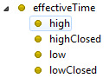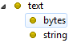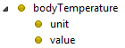
Regarding the shortcuts, looking to HL7 RIM model an Entity should contains only link to Roles, or an act link to a Participation or an ActRelationship to another Act.

With Phi 2 you can ‘shortcut’ each class with the other directly.

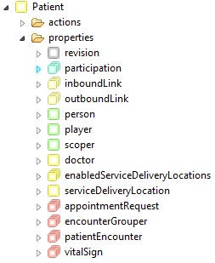
In this picture you can see a Patient (extends Role) which contains shortcut to many other classes. 5 of them depends from original HL7 RIM model:

- 1 Participation
- 2 Entity (player, scoper)
- 2 roleLink (inbound/outbound).

There also:
- 1 Entity (Person)
- 4 List<Act> (appointmentRequest, encounterGrouper, patientEncounter, vitalSign)
- 1 Role (doctor)
- 1 List<Role> (enabledServiceDeliveryLocation)

Class extension

To do this select the class to extend (for example Act, or Annotation) and use the button to extend the class. Specify the new class name

After that the new class is added (if you need you can use refresh button )

Backend entities classes are placed in <PHI_PROJECT>/backed/src/main/java/com/phi/entities

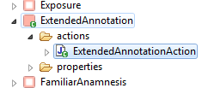
The new class is highlighted with a different icon .
Inside the class you can find action and properties.

In the designer view are automatically open two files: the class you created (in this example ExtendendAnnotation.java) and its class action (ExtendedAnnotationAction.java)
They are present in backend project folder under entities and actions. The class can be open by double clicking the class.

Methods and variables in the action class can be manually written, with the help of creation button defined in the following paragraph..

Add attribute or shortcut
To add an attribute, select the custom class created and use the button
A window compare to choose which kind of attribute you are adding and the name of it.

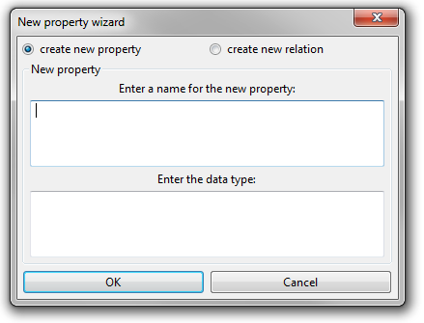

With the same window you can add a shortcut to an object of another class.
This window will be updated.

The new property is added to the class.

Add class method

Selecting the custom action class you can write custom method directly related to this class with the button
Specify the method name, e the returned type.

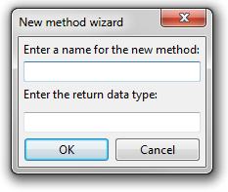

Associate dictionary element to coded value

The Coded values can have also a directly related to a dictionary (a set of code allowed).
In the picture below, atcCode, uses the “Codifa” code system, and “ATC” dictionary.
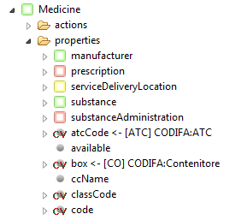
For Coded values where dictionary is already indicated, in case you drag this property on a ComboBox, you don’t need to specify the “List elements expression” attribute of the widget.
The list of elements for the combobox are automatically generated by specified dictionary element in Model explorer.

To obtain this result, you need to open the Dictionary Manager perspective, and inside it a view of Catalog Explorer.

After selecting a dictionary on Dictionary Manager, drag it on the cv attribute of Catalog Explorer.
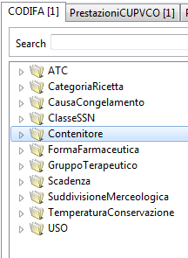
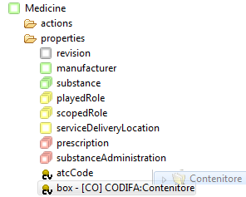

This information are stored in the dictionary.properties file

Example:

Medicine.box=[CO] CODIFA\:Contenitore
Medicine.pharmaceuticFormCode=[FO] CODIFA\:FormaFarmaceutica
Medicine.productClassification=[SM] CODIFA\:SuddivisioneMerceologica

Class modification – simple relation

Classes created can be used to add specific attributes, to separate data in different tables, and to add custom method to the class.

Catalog Explorer will be available to set automatically all the annotation needed to implements relations between classes request by final user.

Following an explanation and some example of relation and attributes that can be added to each class.

The

Add single String attribute without reference to other codes

Specify simply the column name with an annotation on getter method.

private String birthPlace;

@Column(name="birth_place")
Public String getBirthPlace() {
return birthPlace;
}

public void setBirthPlace(String birthPlace) {
this.birthPlace = birthPlace;
}

add attribute like CodeValue to a class

In general an attribute mapped with a CodeValue class need a ManyToOne annotation, because the selected code can be used by many objects. Specify FK and column name.

private CodeValue dischargeDispositionCode;

@ManyToOne(fetch=FetchType.LAZY)
@JoinColumn(name="discharge_disposition_code")
@ForeignKey(name="FK_PatientEncounter_dischargeD")
public CodeValue getDischargeDispositionCode() {
return dischargeDispositionCode;
}

public void setDischargeDispositionCode(CodeValue dischargeDispositionCode) {
this.dischargeDispositionCode = dischargeDispositionCode;
}

Add date Attribute
Data attribute needs additional annotation for timestamp specification.

private Date dismissionDate;

@Temporal(TemporalType.TIMESTAMP)
@Column(name="dismission_date")
public Date getDismissionDate() {
return dismissionDate;
}

public void setDismissionDate(Date dismissionDate) {
this.dismissionDate = dismissionDate;
}

Add Boolean Attribute
@Column(name="available")
public Boolean getAvailable() {
return available;
}

public void setAvailable(Boolean available) {
this.available = available;
}

Add PQ attributes

PQ attributes are mapped with two columns, one for the value, and one for the unit.
IMPROVEMENT: we are planning to map the unit with a coded value.

private PQ fullPrice;

@Embedded
@AttributeOverrides({
@AttributeOverride(name="value", column=@Column(name="full_price_value")),
@AttributeOverride(name="unit", column=@Column(name="full_price_unit"))
})
public PQ getFullPrice() {
return fullPrice;
}

public void setFullPrice(PQ fullPrice) {
this.fullPrice = fullPrice;
}

Add IVL attribute (example IVL<Date>)
Add the attributeOverride annotation to split the IVL information in four columns.

private IVL<Date> existenceTime;

@Embedded
@AttributeOverrides({
@AttributeOverride(name="low", column=@Column(name="existence_time_low")),
@AttributeOverride(name="high", column=@Column(name="existence_time_high")),
@AttributeOverride(name="lowClosed", column=@Column(name="existence_lowClosed")),
@AttributeOverride(name="highClosed", column=@Column(name="existence_highClosed"))
})
public IVL<Date> getExistenceTime() {
return existenceTime;
}

public void setExistenceTime(IVL<Date> existenceTime) {
this.existenceTime = existenceTime;
}

Class modification – advanced relation

The more complex relation in the following chapter needs foreign keys, to map data of one table in another table.
This are called sometimes “shortcut” because they give the possibility to access directly from a class to another, overtaking the normal relation defined in HL7 RIM information model.

List of attributes
The attributes when added ad list, of an attribute type, is an implicit way of one to many relation creation.

This means that an attribute which maps for example a List<CodeValue> need a join table to maps 1:N attribute values.
The join table contains an id of a Coded Value and a column id to reference the original object.

For example: look at the relation between procedure and a branca code: a procedure can be associated to one or more branca code. The relation is many to many because the same branca code can be associated to multiple procedure.

private List<CodeValue> brancaCode;

@ManyToMany(fetch=FetchType.LAZY, cascade=CascadeType.PERSIST)
@JoinTable(name="procedeure_branca_code",
joinColumns = { @JoinColumn(name="Procedure_id") },
inverseJoinColumns = { @JoinColumn(name="procedure_code") })
@ForeignKey(name="FK_procedure_branca", inverseName="FK_branca_procedure")
@OrderBy("id")

public List<CodeValue> getBrancaCode() {
return brancaCode;
}

public void setBrancaCode(List<CodeValue> brancaCode) {
this.brancaCode = brancaCode;
}

procedeure_branca_code
Procedure_id | procedure_code
5 | 1.2.3.4
5 | 1.2.3.7
5 | 1.2.3.8
6 | 1.2.3.6
Procedure
Internal_id | cup_price_value | ...
1 | 10
5 | 12
6 | 34
1
N

In this case procedure code is a code referring an id of a code_value table entry, but in the same way can be made a List of Date reference, List of String of similar relation.

The annotation @OrderBy("id") is needed because this is a list, but must be ordered to be correctly managed in term of add/remove elements from the list.

As written before the List of attributes represents a one to many relation, but the inverse relation is a many to one.
Each relation can be written in both way, and if needed both direction can be written.

Relation One to One

private ConleyScale conleyScale;

@OneToOne(fetch = FetchType.LAZY)
@JoinColumn(name = "conley_scale_id")
public ConleyScale getConleyScale() {
return conleyScale;
}

public void setConleyScale(ConleyScale conleyScale) {
this.conleyScale = conleyScale;
}

Relation Many to One (mono-directional)
A many to one relation is a relation between two classes, but it’s can be navigated only from “children” to “father”.

In this example the patient encounter has an admitter, the doctor which executes the encounter.
During the patient encounter creation the admitter is set.

Normally is not needed to know the list of encounter referred by an employee, so the relation is mono-directional.

In this case the relation si set from the child to the parent class (Many to One).

PatientEncounter.java

@ManyToOne(fetch=FetchType.LAZY)
@JoinColumn(name="admitter")
@ForeignKey(name="FK_Pat_Enc_Admitter")
public EmployeeRole getAdmitter() {
return admitter;
}

public void setAdmitter(EmployeeRole param) {
this.admitter = param;
}

EmployeeRole.java

There are no attributes referring to the Employee Role.

If needed the list of encounter referred by a specific employeeRole can be easily retrieved with a read of PatientEncounter:

PatientEncounterAction.equal.put(‘referrer’,EmployeeRole)
PatientEncounterAction.read()

The first Action put a filter on the read, and specify that the referrer of the selected PatientEncounter must be the given EmployeeRole.

More over if needed the reverse relation con be implemented adding a reverse relation to the EmployeeRole.java as described in the following paragraph.

Relation One to Many (monodirectional)

If you need to set in a parent class a one to many relationship with a list of child (but in the child you don’t need the reverse relationship) you can do in this way:

Parent.java

private List<Child> children;

@OneToMany(fetch=FetchType.LAZY, cascade=CascadeType.PERSIST)
@JoinColumn(name="parent_id")
@ForeignKey(name="FK_Parent_id")
@AuditJoinTable(name="z_Parent_id_jt")

public List<Child> getChildren() {
return children;
}

public void setChildren(List<Child> children) {
this.children = children;
}

Relation Many to One (bidirectional)

To add the reverse relation a List of PatientEncounter must be added to the EmployeeRole Class

EmployeeRole.java

@OneToMany(fetch=FetchType.LAZY, cascade=CascadeType.PERSIST, mappedBy = "admitter")
public List<PatientEncounter> getAdmitterFor() {
return admitterFor;
}

public void setAdmitterFor(List<PatientEncounter> param) {
this.admitterFor = param;
}

The annotation contains the “mappedBy” property: it is the name of how this relation is mapped in the referenced class. In fact in PatientEncounter class, the Employee role is mapped with admitter.

Relation Many to Many

Many to many (N:N) is bidirectional relation, both class need annotation on respective getter methods.
Two List<xxx> must be added to both classes as private variables.

A medicine can have one or more substance as ingredient. The same substance can be contained in many different Medicine.

Join table name used for mapping N:N elements
In class Medicine.java

private List<Substance> substance;
Current Class
@ManyToMany(fetch=FetchType.LAZY, cascade=CascadeType.PERSIST)
@JoinTable(name="medicine_substance",
joinColumns = { @JoinColumn(name="medicine_id") },
Relationed Class
inverseJoinColumns = { @JoinColumn(name="substance_id") })
@ForeignKey(name="FK_Substance_Medicine", inverseName="FK_Medicine_Substance")
public List<Substance> getSubstance() {
return substance;
Direct/Inverse forcing keys
}

public void setSubstance(List<Substance> param) {
this.substance = param;
}

public void addSubstance(Substance substance) {
if (this.substance == null) {
this.substance = new ArrayList<Substance>();
}
// add the association
if(!this.substance.contains(substance)) {
this.substance.add(substance);
}
}

In class Substance.java

private List<Medicine> medicine;

@ManyToMany(mappedBy = "substance", cascade=CascadeType.PERSIST)
public List<Medicine> getMedicine() {
return medicine;
}
public void setMedicine(List<Medicine> param) {
this.medicine = param;
}

NOTE1: the annotation present in the Medicine class define implicitly a new table, which is needed to join the data of Medicine and Substance table. In this case an intermediate class is not needed.

NOTE2: the add method must be added!!

Medicine
internal_id | code | ...
1 | 10
5 | 12
6 | 34
1
N
Medicine_Substance
medicine_id | substance_id
1 | 1
1 | 2
5 | 2
6 | 3
1
N
Substance
internal_id | code | ...
1 | 5
2 | 2
3 | 4

Create intermediate class for many to many relation

In the previous case the relation Many to Many can be written directly with an annotation.
Sometimes the relation need attributes. So in this cases an additional class must be added.

For example an Infusion prescribed to a Patient contains more than one Medicine with different quantity for each of them.
So the relation between infusion and medicine is N:N. But each of this relation need to have a property representing the quantity of each medicine.

Prescription
internal_id | code | ...
1 | INFU
5 | INFU
6 | INFU
1
N
Medicine
internal_id | code | ...
1 | 5
2 | 2
3 | 4
Infusion_Components
infusion_id | quantity_value | quantity_unit | medicine_id
1 | 5 |  | 1
1 | 2 |  | 2
5 | 4 |  | 2
1
N

Prescription.java

private List<InfusionComponents> infusionComponents;

@OneToMany(fetch=FetchType.LAZY, cascade=CascadeType.PERSIST, mappedBy = "prescription")
public List<InfusionComponents> getInfusionComponents() {
return infusionComponents;
}

public void setInfusionComponents(List<InfusionComponents> infusionComponents) {
this.infusionComponents = infusionComponents;
}

public void addInfusionComponents(InfusionComponents infusionComponents) {
if (this.infusionComponents == null) {
this.infusionComponents = new ArrayList<InfusionComponents>();
}
// add the association
if(!this.infusionComponents.contains(infusionComponents)) {
this.infusionComponents.add(infusionComponents);
}
}

InfusionComponents.java

private Medicine medicine;
private Prescription prescription;

@ManyToOne(fetch = FetchType.LAZY)
@JoinColumn(name = "prescription_id")
@ForeignKey(name = "FK_InfusComp_Presc")
public Prescription getPrescription() {
return prescription;
}

public void setPrescription(Prescription prescription) {
this.prescription = prescription;
}

@ManyToOne(fetch = FetchType.LAZY)
@JoinColumn(name = "medicine_id")
@ForeignKey(name = "FK_InfusComp_Medicine")
public Medicine getMedicine() {
return medicine;
}

public void setMedicine(Medicine medicine) {
this.medicine = medicine;
}

Medicine.java

private List<InfusionComponents> infusionComponents;

@OneToMany(fetch=FetchType.LAZY, cascade=CascadeType.PERSIST, mappedBy = "medicine")
public List<InfusionComponents> getInfusionComponents() {
return infusionComponents;
}

public void setInfusionComponents(List<InfusionComponents> param) {
this.infusionComponents = param;
}

Actions
Actions inside catalog explorer can be dragged directly on node actions.

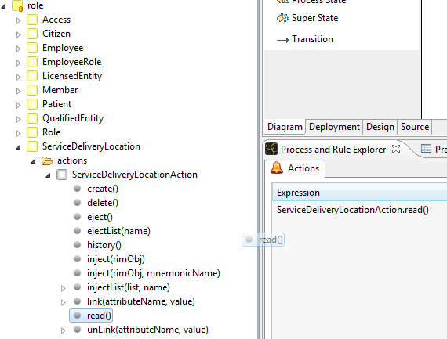

Read(), select() create(), delete()
Read, create and delete are the base actions to manage the rim objects.

Read inject in conversation a list of object result of the list, with the name <className>List.
E.g.: PatientAction.read() injects a PatientList object with all the patiens.

Create store in the db the current instance of the class object. If the object exist, it’s updated.
e.g.: PatientAction.create() store in the db the conversation object called Patient

Delete remove from the database the instance of the class object in conversation.
e.g.: PatientAction.delete() remove from the db the entry in Patient table corresponding to the current Patient in conversation.

NOTE: the flush are made at the end of the process, by Hibernate.

Additional operation on Read (Select and Page size)

Read operation get all the object of one specific class. Restriction can be applied (See chapter on read and search filters).

Moreover you can do some more operation before execute a read operation.

Select
Select operation allow to get some object properties instead of the entire object list. This method allow to use less memory and speed up the read query.
To set the property to be selected use the catalog explorer, and in the Action of your object open the select item. It will contain the list of property (and related object). Drag and drop them, one by one, adding them before the read() opertation in the node of your process

The result of this operation will be action like: PatientAction.select.add(‘name.fam’)
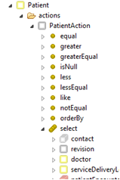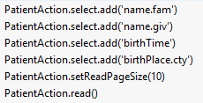

Read Page size
Read operation, executed on big tables can be heavy for the system, and also for the client load a result datagrid with many result. Page size is the property to be set to obtain a paged read.

The paged read is managed by phi, making more small read, every time you ask a new page of your data grid, instead of execute only one big query.

You have to set in the node where read is executed (before read operation):

PatientAction.setReadPageSize(10) for example for a paged read of ten result per page.

The same configuration MUST be set in the datagrid property “Number Of Row Per Page:

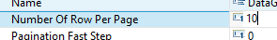

The result datagrid will contain on top right corner a page counter, and some arrow to move forward and backward in the result list.

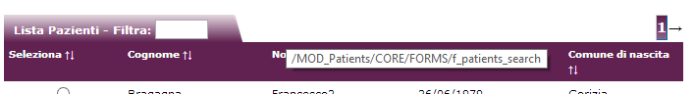

Order by
Order by clause can be added one or more, always with drag and drop from Object action list.

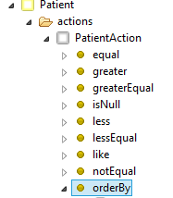
Open orderBy element and drag to the node action list the property you want to use as sorting element of your query.

The action will be written in this way:
PatientAction.orderBy.put('birthTime','ascending')

You can change manually ascending/descending ordering.

Link/unlink
Link and unlink permits to set connections between object (FK). For example if I want set the current Employee in conversation as doctor of the Patient in conversation I can write in the action:

PatientAction.link(‘doctor’, Employee)

This operation can be directly dragged from catalog server, example in the picture below: link the patient to the patientEncoutner.

Link/Unlink work directly with list.
If I want for example add the current VitalSign to the list of VitalSign of the Patient, I can drag
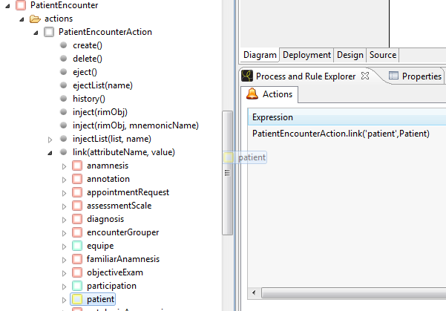

Inject/eject objects and list in conversation
To inject/eject object in/from conversation are exceuted with the following action available for each Rim object class.

eject() eject the object associoated to the action.
E.g. PatientAction.eject() remove from conversation the patient object

ejectList(name) eject a list from conversation, with a specific name.
E.g. PatientAction.eject(PatientList) remove the list of patient from conversation. If present, the Patient object is not removed.

inject(rimObj) inject in conversation a specific rim object.
E.g. PatientAction.inject(PatientEncounter.patient) injects the patient with the conversation name “Patient”, associated to the PatientEncounter already present in conversation.

inject(rimObj, mnemonicName) inject in conversation a specific rim object, with a given mnemonic name.
E.g. PatientEncounterAction.inject(PatientEncounter.assignedSDL,”ServiceDeliverLocation”)
Puts in conversation with the name ServiceDeliveryLocation the assigned SDL.

injectList(List, name) inject a List with a specific name
E.g. PatientEncounterAction.injectList(PatientEncounter.vitalSing, “VitalSignList”)
Puts in conversation with the name VitalSignList the list of vital sign associated to the PatientEncunter in conversation.

Check if object is present in conversation
To check if an object instance (for example a Patient) is present in conversation, you can use a simply EL to be applied as a decision in a process, or a RenderEL/DisalbedEL/.. property of one widget:

empty Patient

Using the reserved keyword ‘empty’ in an expression language string, seam will check if the following object is present or not in conversation.

History of rim Objects
History of each object is traced automatically by phi technology. When a phi object is created/updated/deleted the trace of its changes can be retrieved with history methods.

When a Rim object is updated with provided methods, the object is updated in its table, but the previous version is stored in the corresponding audit table, with a revision reference.

The collection of all revision represents the object history.
So history actions put in conversation a list of revisions of one rim objects.

Example: you have in conversation a Patient.java object instance with conversation name Patient.
The Patient is a specific instance of class Patient, with an unique internal_id.

Calling PatientAction.history() in conversation is placed a list called PatientHistoryList.
Each element of this list is a Patient instance, and each of them represents a revision of the patient along the time.
Put PatientHistoryList as binding of a table, and you can access to all the information of each revision.

History methods are four:

.history() return the list of historic revisions of the object
.historyIncludeCurrent() same of previous: at the end of the list is added the current object version
.historyFiltered(<filterList>) revision contained in the list are only which one contains changes in one or more attributes provided.
.historyFilteredIncludeCurrent(<filterList>) same of previus, including current object version

Filtering example:
Suppose to have in conversation a Person. Its history() contains revisions saved when a telephone or an address is changed.
But this person change names two times.
To retrieve only the historical revisions where the name or surname is changed call this method:

PersonAction.historyFiltered(‘name.giv’, ‘name.fam’)

Suggestion
Sometimes maybe you can need to get the history of a parent object, but you are interestend in revision when only changes affect a child object attributes.

In this case if when you store a the changes to the child object most of the time the parent object doesn’t change.
Calling parent history will return maybe only one revision, the first, and all the changes to the child objects are not visibile.
To link the story of a child to its parent you need to save every time you change a child, a modification to a parent.

In this case so calling the filtered history of the parent, by child changes, the revision returned are consistent.

Ordering
History ordering is default from older to newer release.
If you want get the result in descending order, from newer to older you have to add a node before history read like this one:

PersonAction.setHistoryOrderDescending(true)

Temporary values
Each object contains a temporary attributes called “transientValue” and “transientValue2”.
These two attributes are deprecated.

Temporary value can be stored in a temporary hashmap, associated to the action of each object.
The hashmap is used to store the association between a variable name, and its value. Type of this data can be different for each variable contained in the hashmap.

Examples: you need to store in a variable a value inserted by the user in a form, and reused later in a different process.

Prerequisite: the process/subprocess where the variable I s read, and the process/subprocess where the variable is used, must be part of the same main process. If the mainprocess ends, the variable is cancelled.

In a form, in a binding of an input text insert: PatientAction.temporary['myVariableName']

In a process node use the variable, with reasignig its value less 1:
PatientAction.temporary.put('myVariableName',PatientAction.temporary['myVariableName']-1)

In a decision node check if the variable is still greater than zero:
PatientAction.temporary['myVariableName'] gt 1

Designer widgets properties

Some widget properties are updated/changed.
In the following paragraph the new properties added, and their meaning.

List Elements Expression

List Elements Expression can be filled with an expression language string, returning a List of SelectItem.

For a standard combobox where the list of select item is associated to an entire list of dictionary voices, it could be written in this way:
vocabularies.getIdValues('HL7:AdministrativeGender')

This is no loger needed because the association between dictionary/binding/combobox can be done automatically with drag & drop.

So the only cases where this widget attribute is usefull is when you need a specif list of values not associated with an entire dictionary.

Note: when you specify a list element expression, you must specify a converter for the expression. (e.g. CodeValueConverter, EntityConverter,…)

Default Value
Default value in widget properties is the field where the designer’s user can set a specific value for the widget at runtime, giving to the user the possibility to have an already selected option.

This behavior can be also implemented at process level: before the form where the default value must be selected, put a node, or a pre-action, which set the binding corresponding to the widget value, with the desidered default value.

The default value is a property available only for input widget. Actual implementation limit to the following possibilities. Depending on widget type this value can be different.

TextBox, TextArea, IDBox: can be written a free string text.

CheckBox: can be set to “true” or “false”

ComboBox, RadioGroup: if the widget is already associated to a binding, the code specified in the default value can be simply the code itself. E.g.: M for male code in a widget associated to genderCode.
Otherwise you can use the method: getCodeValueExtendedId of vocabularies, to specify one code to be selected. E.g.: vocabularies.getCodeValueExtendedId(“PHIDIC”, “gender:M”)

ListBox, GroupCheckBox: one or more coded value can be selected with the string sintiax <code>|<code> .. using pipe as code separator, if the binding is associated to a specific dictionary.
Otherwise, you can use the method: vocabularies.getCodeValueExtendedId(“PHIDIC”, “gender:M,F”, “…”, “…” ) to select also multiple code from different dictionaries to be selected by default.

MonthCalendar: it is possible to set as default value the current date using “today is Default Time” property

Read and search Filters
During process execution normally you execute read operation on object class.
Like in a normal dbms query, you can add restriction to that read from a process (a restriction that will be applied, depending only from process path), and restriction applied from form fields, like combobox/input text, defined by final user.

Read filters
In a action node you can add filters to your read operation. Read filters are added with drag and drop from catalog explorer.

Example: I have to read all patient, with family name like “F%”.

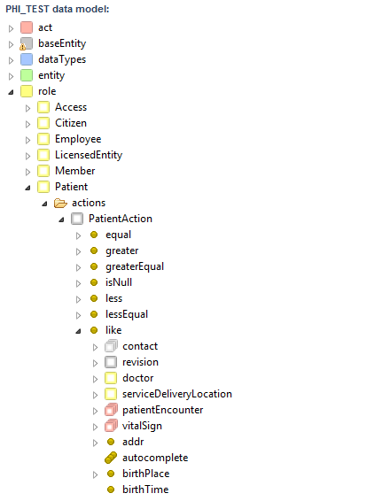
Open Patient -> actions -> like -> name -> fam

And drag the fam property into node action.
Than complete the expression with ‘F%’
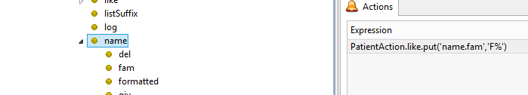

The sintiax of filter, called by a process is the following:

Example:
PatientAction.like.put('name.fam','F%')
PatientAction.equal.put('statusCode.code','active’)

To disable a filter (remove the restriction from read operation) you have to put that filter to null.

Example:
PatientAction.equal.put('statusCode.code',null)

This doesn’t mean the code of statusCode of the patient is null, but the filter on the statusCode.code is disabled.

To set that the statusCode is null or is not null you can drag & drop from isNull CatalogExplorer action:

PatientAction.isNull.put('statusCode',true) //is null
PatientAction.isNull.put('statusCode',false) // is not null
PatientAction.isNull.put('statusCode',null) // to remove the restriction

All the restriciton added to a read are maintained also in sub-process or super-precess, if not removed by setting them as null.

So if you add more than one restriction, they all applied togheter in AND condition.
E.g.:
PatientAction.like.put('name.fam','F%')
PatientAction.like.put('name.fam','%o')
PatientAction.greater.put(‘internalId’,45)

The name.fam property must be like F%, and like ‘%o’ and the internal id must be greater of 45.
E.g.
Patient with name Franco and internalId 35 is not selected.
Patient with name Francesco and internalId 55 is selected.
Patient with name Frank and internalId 100 is not selected.

Finally if you want add some restriction in Or, instead of And, you must add them manually in this way:

PatientAction.equal.putOr('code.code','active','suspended')
Will get patient which have the code active OR suspended.

Same operation can be written in this way:

PatientAction.equal.put('code.code',ListValues)
Where ListValues is an array list containing the list of valid codes used for or clause.

In/notIn clause need a list compatibile with property filterter:

ModuleAction.in.put('internalId',function.longAsList('21,23'))
IstanzaAction.in.put('structureReq.name',function.stringAsList('Struttura 1,Struttura 3'))
IstanzaAction.in.put('structureReq.name',function.objectsAsList('Struttura 1','Struttura 3'))
StructureAction.notIn.put('internalId',function.propertyAsList(StructureReqList.list, 'structure.internalId'))

Search filters
Search filters are applied/not applied dynamically depending on the fact that a user fill or not a field at runtime. Search filters are called in this way because they are in general applied in form which execute object search based on user inputs, but they are read restriction applied on select queries like read filters.

Search filters are placed by drag and drop from properties of catalog explorer to a widget on a form. When you drop, a window like this opens, and you can see the binding configuration.
For a general object binding, you can choose “object data”. In this case, to be applied like a filter select “filtered by” and choose the resctriciton type.

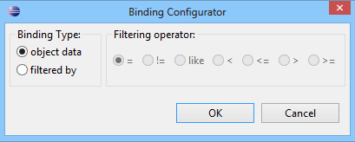

Example of binding result after clicking ok:

PatientAction.like['name.giv']
PatientEncounterAction.like['id[ANAG]']
PatientAction.greaterEqual['creationDate']

Business logic
Business logic can be written with java code mainly in two places:
- As methods in the Action classes.
- As additional classes and methods in the backend.

More over some already implemented methods are present in function bean, and they can be used to manage directly the data.

Their combination of Backend and Action methods together with functions is the best practice to write reusable code.

Some business logic can be manually written in the action list of nodes.

In the following paragraph are listed some action example and the most useful function.

Action methods
Methods inside action class must be (best practice) strictly related to the class.
For example these are two methods inside PatientAction to get the last VitalSign of a specific type:

public String getLastHGT() throws IllegalAccessException, InvocationTargetException, NoSuchMethodException{

VitalSign vs = getLastVitalSign("height");
if (vs != null) {
PQ pq = vs.getHeight();
if (pq != null && pq.getValue() != null)
return pq.getValue().toString();
}
return "";
}

private VitalSign getLastVitalSign (String attribute) throws IllegalAccessException, InvocationTargetException, NoSuchMethodException {

if (attribute == null || attribute.isEmpty())
return null;

VitalSign newest = null;
Date newestDate = null;
List<VitalSign> vitalSigns = getEntity().getVitalSign();
for (VitalSign vitalSign : vitalSigns) {
PQ measure = (PQ)PropertyUtils.getProperty(vitalSign, attribute);

if (measure != null && measure.getValue() != null) {
Date d = vitalSign.getAvailabilityTime();
if (d==null)
continue;
if (newest == null || newestDate == null || d.after(newestDate) ) {
newest = vitalSign;
newestDate = d;
}
}
}

return newest;
}

Set code value attribute based on OID

Because the Phi dictionary can be versioned, the OID is the the unique id valid for a specific code, in multiple version of same dictionary.

PatientEncounterAction.setCodeValueOid('statusCode','2.16.840.1.113883.3.20.22135.22235.22236.22242.completed')

Set code value by CodeSystem, Domain, Code

To identify in unique way a code from dictionary the tuple CodeSystem,Domain,Code is an effective way to do it.

So, to set a code value attribute use this method:

AssessmentScaleAction.setCodeValue('code','PHIDIC','HIS','CONLEY')

Get EmployeeRole related to Current system user

Log in on the system is made with a specific system user account. The system user are instance of Employee employee class. Each Employee can have one or more EmployeeRole (another class), which are specific role associated to the user.
During the login, the user must select a role associated to its account.

To obtain the current Role, used by the logged user:

userBean.getCurrentSystemUser()

Assign an author

Because the signing of a document, a patient encounter, or additional operation like these must be associated to an author, it’s necessary to link an author. This is an example for a patient encounter:

PatientEncounterAction.link('admitter', userBean.getCurrentSystemUser())

Note: an alternative method could be set the admitter of the patient encounter. The best practice is use the link method instead of:

PatientEncounter.setAdmitter(userBean.getCurrentSystemUser())

This because in case of complex linking, or linking of null object, the link method mange these cases.

Format date

Format date permits to obtain the Data object formatted as requested.
e.g.
function.formatDate(Annotation.availabilityTime, 'dd/MM/yyyy HH:mm')
function.formatDate(PatientEncounter.dismissionDate, 'dd/MM/yyyy')
function.formatDate(Dosage.dayTime, 'HH:mm')

Current time
Sometimes current timestamp it’s needed to be saved associated to an object attribute.
E.g. During the creation of a note in the medical diary, the current timestamp is saved in the attribute which contains the information of when the note is written.

Annotation.setAvailabilityTime(function.currentDateTime())

Current process name
The current process name can be used for example to change the visibility of some widget, depending of which process you are using. The current process name can be accessed with this method:

processManager.currentProcess

The string result contains the process path, starting from the module, to the process name.
For example:
MOD_PointOfCare/CORE/PROCESSES/Prescription/Prescribe new

The current process is intended to be the ‘main’ process called by the user.

Current sub process name
When a main process call one or many sub-process, it could be useful know the sub process name, call

processManager.currentSubProcess

In case no sub process are started, the main process name is returned.

Get integer part
When you have a floating point number in a properties and you want to get the integer part, you can use:

function.getIntegerPart('4.56343343')
function.getIntegerPart(VitalSign.pain.value.toString())

End of line in Labels
Normally the labels are thought to not contain multilinetxt.
If a text must be multiline, the label wrap the text automatically, splitting the line at the size decided by the label size.

In other cases if you need a text on multiple line, with different sizes, you can add as many label as the number of line you want, writing in each labels what must be present on the line.

Some rare case need a text on multiple line, but the text is dynamic, and in this case the two solution above are not enough.

Most of the case are also solved with text area widget.

If you need to add “manually” one or more end of line in one label, the solution applied is different from where you apply the label (Probably this will be fixed in the future).
Trying to add a \n or <br/> to a string is not enough, It was a solution in the previous version of phi.

Label outside of a table with a binding value
This case apply when you have to place a label in a form, and the content of the label comes from a data saved in an object attribute, or coming from a function of an action / bean.

- set the binding value as needed (e.g. PatentEncounter.text.string or myBean.calculateSomething()
- set as jolly parameters the string escape="false"

The binding call must return a string containing <br/> anywhere an end of line is needed.

Label with text coming from translation
The case apply to a label where the value is set in the widget properties as translation (e.g. Italian, English..).

- set the value with the Multilanguage popup of value attribute
- set as jolly parameters the string escape="false"
- add anyway a binding value: set it as messages.label_Xxxx (e.g. messages.Label_1353664368882) with the same label name of the edited label

The translation in each language must contains <br/> tag where the end of line character must be placed. You can check in the messages_<language>.properties file (e.g. messages_en.properties).

The need to add anyway a binding is caused by the fact that a label without a binding is converted to a <span> tag, instead the label with a binding are in general generated as <h:outputText. Only with h:outputTextand the property escape can be set to false and the text coming from messages translation is escaped, without it, like in a span, you see the text <br/> or \n

Label inside a table
The case apply when you want to insert in a table cell multiple label one below the other.
If you add in a data grid column more than one label, they are placed in the right way, but they are generated as continous text in the same cell.
There is no way to do it without a jolly widget actually.

- Create a JollyWidget in the data grid column.
- As code of the jw set:
<h:outputText value="#{xxxxx}" escape="false" /><br/>
<h:outputText value="#{yyyy}" escape="false" /><br/>
<h:outputText value="#{zzzz}" escape="false" /><br/>

One output text for each line, followed by <br/> tag.
If you need as many output text, as a dynamic result, you need a specific action which returns a stering containg the <br/>.

e.g.:
Create in a search patient result list (PatientList table), for each row (Patient) a cell containing the list of date of all its Patient Encounter acceptance date.

The jolly widget in the cell containing the encounter will be:
<h:outputText value="#{PatientAction.getPatEncDates(Patient)}" escape="false" />

The method of patient action:

public String getPatEncDates(Patient pat) {
if (pat == null)
return "";
List<PatientEncounter> listpatenc = pat.getPatientEncounter();
if (listpatenc == null)
return "";
String ret="";
for (PatientEncounter patenc : listpatenc) {
ret+=patenc.getAvailabilityTime()+" <br/>";
}
return ret;
}

The result in the cell will be:

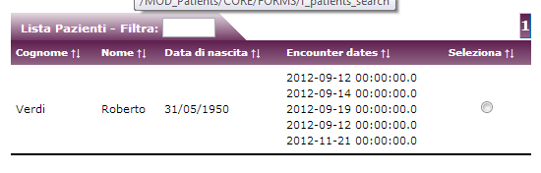

Table header
End of line inside a table header is not allowed.

Table column width
With release 2.2 of catalog server Table column width can be set, to have column with fixed width, instead of dynamic sizing, you can set a fixed Width in data grid column property.

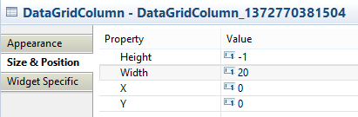

You have to set an entire number:
- it means pixel in case of Resize: manual,
- it means percentuage in case of Resize: auto

So like in the picture above, a DataGridColumn with “20” will be a column of 20 pixel, for an manual resize datagrid, or a column wide 20% of entire table width.

Widget style
Widget are generated as xhtml pages as designed at design time. All widgets have common style properties (E.g. font and character size) placed in common in default.css stylesheet.

You can customize basic style properties for each widget in Appeareance tab of widget properties.

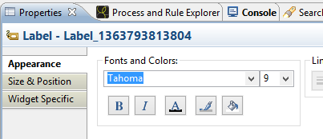

These changes are applied during form generation only if you have selected Used Internal Style = yes in “Widget Specific” tab.

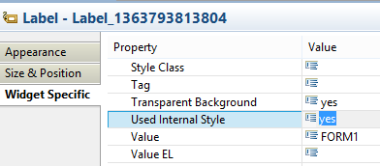
Additional to the you are free to customize default.css stylesheet adding custom entries, more specific, or anyway not available in Appeareance tab.

To add style customization to a widget in a form, not available in the appeareance tab, you can use the two widget properties “Style” and “Style Class”.

StyleClass define the name of a specific style class present in the default.css stylesheet. So you can define a new style class in the css called “myCoulouredStyle” and reuse this class with one or more widget of your form, specifing “myCouloredStyle” in the property Style Class. The xhtml generated, inside the widget code will contain class="myCouloredStyle"

If you want use instead the classic configuration of the widget, but add only a grafic property to the standard style, you can add in Style property of the widget the code needed.
For example if you add to a label



The result will be border styling with one pixel.

Another example: to align the column data of a data grid, to a right alignment, you can write:

text-align:right; display:block; width:100%;

Widget with object reference

Combobox were in 1.7 designed to be used only with code Value attributes.
Also group checkbox, or Radio Group or similar widget were working only with coded values.

With phi2 you can place a relationship as binding of one combobox, and an entities of specific class as element of the combobox.
The relationship must be 1:1 or N:1 relationship, not a 1:N.

Example with ComboBox.

Place a combobox in your form and select as binding a relationship as Patient.doctor.
In this example the doctor relation of Patient class is a relation N:1 with Employee class

Choose as converter an “Entity Converter “

As List Elements Expresison write an expression like this one:
vocabularies.entityToSelectItem(EmployeeAction.list(),'person.name')

Anyway if you already have EmployeeList in your conversation, you can call (better)
vocabularies.entityToSelectItem(EmployeeList.getList(),'person.name')

This methods return a list of select items, starting from the list of all Employee, and put as label in the combo box the person.name attribute of each of your element of your list.

The result will be something like the following

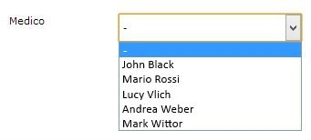

When the Patient will be saved, the relation between patient and doctor will be set.

SelectItems containing selected code of multiple domains
In general domains are made to divides codes, and make selection of multiple codes with couple (CodeSystemName,DomainName).

But sometimes is requested to have subset of codes, coming from single or multiple domains (of one unique code system!)

For example you have:
CodeSystem: CodeSystemName
[DomainA] domainA
[Alfa] Code1 (code=Alfa, displayName=Code1, translation = ….)
[Beta] Code2
[Gamma] Code3
[DomainB] domainB
[Omega] Code8
[Epsilon] Code9
[DomainC] domainC
[Zeta] code99

If for any reason you need for example combo box with code Alfa, Omega, Empsilon and Zeta you can use this method of vocabulary class:

vocabularies.selectCodeValues(‘CodeSystemName’, ‘domainA:Alfa’, ‘domainB:Omega,Epsilon’, ‘domainC:Zeta’)
This method returns a list of SelectItems, and can be called directly from designer in List Element Expression property. You must set as “Code Value Converter” as Converter.

The combobox at runtime will have proper translation of each code.

Phi designer configurations

Password encryption
Password encryption is enabled/disabled with the properties file

When false the employee password are stored in the db without encryption in clear text.
When true the employee password are stored with md5 encruption.
The encryption is of course not reversible.

When a solution is deployed with password in clear text (with user’s creation) if you want to enable the encryption you have also to update the db password.
The encryption must be made only one time, encrypt the encrypted version will transform your password in something not more usable.

Mysql:
update employee set password=MD5(password);

Oracle:
update employee set password=LOWER( RAWTOHEX( UTL_RAW.CAST_TO_RAW( sys.dbms_obfuscation_toolkit.md5(input_string => password))));
commit;

When password are encrypted, the only way to help an employee with lost password, is update its password with a new default password.

Example of encrypted password:
admin1: e00cf25ad42683b3df678c61f42c6bda
admin: 21232f297a57a5a743894a0e4a801fc3
12345678: 25d55ad283aa400af464c76d713c07ad
password: 5f4dcc3b5aa765d61d8327deb882cf99
admin123: 0192023a7bbd73250516f069df18b500

To do it simple execute an update like this:
update employee set password ='21232f297a57a5a743894a0e4a801fc3' where username = 'admin';

Note:
If in Oracle production environment, you have issue using command above, create a function and call it:

create or replace function my_md5(p_string in varchar2)
return varchar2
is
begin
return (dbms_obfuscation_toolkit.md5(input_string => p_string));
end;
/
update employee set password=LOWER( RAWTOHEX( UTL_RAW.CAST_TO_RAW( my_md5( password))));
commit;

see https://forums.oracle.com/thread/229342 for more details.

ID roots
Set<II> can be used in Entities as data type. Each II, according to HL7 spec. is composed by a root (key) and extension (value).

To add new root, visible in your Catalog Explorer, right click on the solution, select properties.
In the new window, go to “phi Designer” -> “ID Roots” branch.
Add here to the list new Id roots with right click -> add Item.

Best practice and suggestions

Catalog server base classes usage
Sometimes if you need to use base classes (e.g. Observation, Patient,…) you don’t know if in a shared environment/DB, where other can use the same classes, if they will use also the same classes you are starting to use.

For this reason, follow these two guidelines:

1) if you use directly a base catalog server class instead of extend it for your use, when you flush data set a specific code for your data
2) if you share the db data togheter with other, before use an existing class to store your data, ask to your colleagues if anyone already use it, to avoid problem in integration.

Runtime configurations

Integration Servlet
For runtime environment in Catalog Server (after 2.2.0 version) is available generic servlet to authenticate users, and start process if needed.

The servlet is used in general by other system to call phi, start process and log users without user interaction. It can be called with with a properly formatted url, also directly from a browser, or from a frame inside another application.

The servlet in included in Catalog Server distribution, and must be declared in web.xml of solution where the servlet must be available.

<servlet>
<servlet-name>IntegrationServlet</servlet-name>
<servlet-class>com.phi.cs.integration.IntegrationServlet</servlet-class>
</servlet>
<servlet-mapping>
<servlet-name>IntegrationServlet</servlet-name>
<url-pattern>/integrationServlet</url-pattern>
</servlet-mapping>

If properly added and according to the definition above you can invoke it with this url:

http://localhost:8080/<phi_solution>/integrationServlet?parameter1=val1;parameter2=val2

Following paramters are mandatory:

- username: user for the employee you want to log-in: e.g. username=admin
- roleCode: code of the Code of the EmployeeRole used for log in. e.g: roleCode=1

Following paramters are optional, depending of your needs:
- lang: language used for login, according to standard Java Locale.
e.g.: lang=it
defalt language is ‘en’ (English) if the parameter is not specified

- processName process name to be started according to processManagerImpl processName.
e.g. processname= processName=MOD_Patients%2FCORE%2FPROCESSES%2FCreate_Patient
path, which contains slash, must be of course encoded.

- sdlLoginList internal Ids of ServiceDeliveryLocation selected at login, separated by ;
e.g: sdlLoginList=10;13;1293

The servlet works without ask password for the user. The password protection in servlet call can be enabled through 2 properties in seam.properties file of Catalog Server jar deployment.

enableIntegrationServletPasswordProtection=true
set as mandatory the password parameter for integration url.
provideEncryptedPasswordToIntegrationServlet=true
define if the password contained in the url must be or not passed already encrypted in md5

Enabling the protection, the url MUST contains the user’s password
Enabling the second option, the password MUST be alredy encrypted in md5, and the db must contain already encrypted passwords.
If this option is not enabled, and the db contains encrypted password, the password MUST be inserted in the url in clear text.

There are some additional parameter, that can be added to servlet call:
- Object to be injected
Object injection can be made from servlet with following sintiax:
<ClassName>=<Object InternalId>
e.g.: Patient=19
<ClassName>List=<list of internal ids of object separated by ‘;’>
e.g.: PatientList=19;23
If internalId are not found, null object are inject. If invalid id (not convertible to java Long) are passed, object are not injected. (both case log error is present in the log, but servlet call doesn’t fail).
ClassName must start with uppercase of course.

- Flex variables to be set
Flex variable can be set with f_<variableName>=value. E.g.: f_username=admin

- Temporary variables to be set
Each class can have in conversation an hashmap instance, with couple variable/value. For example PatientAction need to have a temporary variable called ‘isTransferred’ with value ‘true’ (binding: PatientAction.temporary[‘isTransferred’] )the information can be set from servlet url:
<ClassName>Action.temporary.variableName=value
e.g.: PatientAction.temporary.isTransferred=true

NOTE: of course all values of parameters must be encoded according http url standard specification.

Subversion repository suggestions
In a phi project all the file can be committed on your subversion server.
But there are two folder which is better to do not commit:

documentation in the root folder of your project: it contains the automatic generated documentation. These files are frequently updated when you change forms/process: you probably don’t’ need to update them on subversion server, until the solution is completed, to avoid additional unuseful commit.

webapp\src\main\webapp this subfolder is at the same level of modules/rules folder. But this contains the automatically generated xhtml. For the same reason above, could not be usefull commit every change in this folder.

To above synchronization issue with your subversion server, we suggest to add to subversion ignore list this two folders, until you not need to definitely commit them.

PHI Previous version behavior not supported jet.

ValueEL
All the valueEl expression contained for example in label, must be moved to binding widget attribute. The expressions are valutated as written in the binding an placed as value for the widget.

ValueEL attribute is still present in the widgets (for retro compatibility), but not used in the page generation.

